Python Assignment 2 - Manish Malviya

1. Grade Checker

Explanation:
- Takes user input using input()
- Converts it to integer using int()
- Uses if-elif-else conditions to check range
- Prints corresponding grade
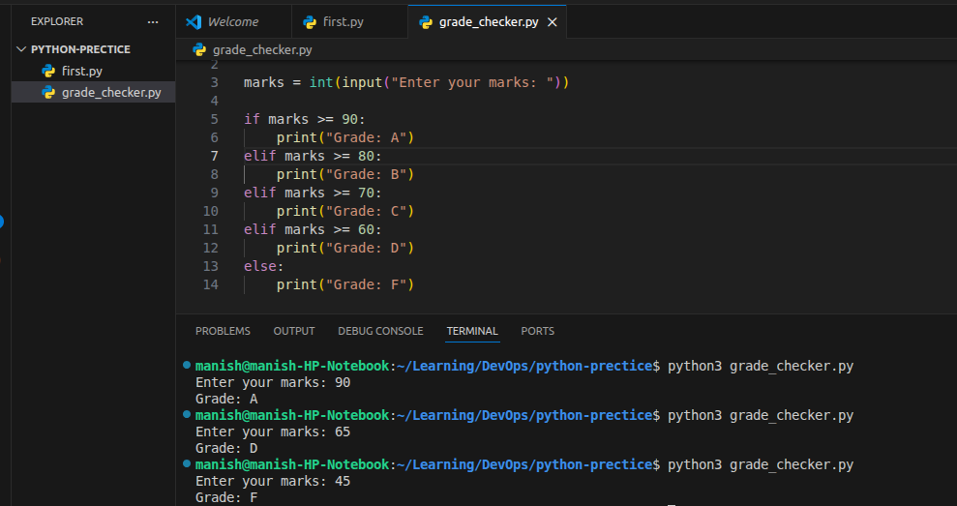

2. Student Grades

Explanation:
- Uses a dictionary (students = {})
- Supports:
  - Add → students[name] = grade
  - Update → check with if name in students
  - Display → loop using .items()
- Menu-driven using while True
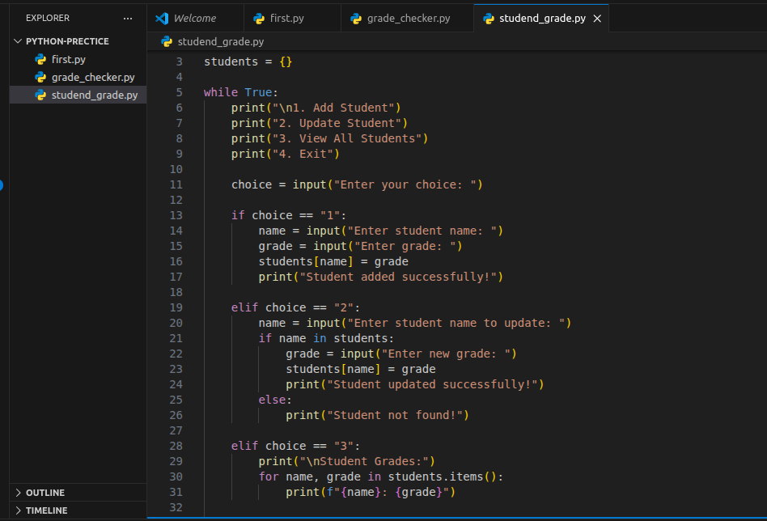
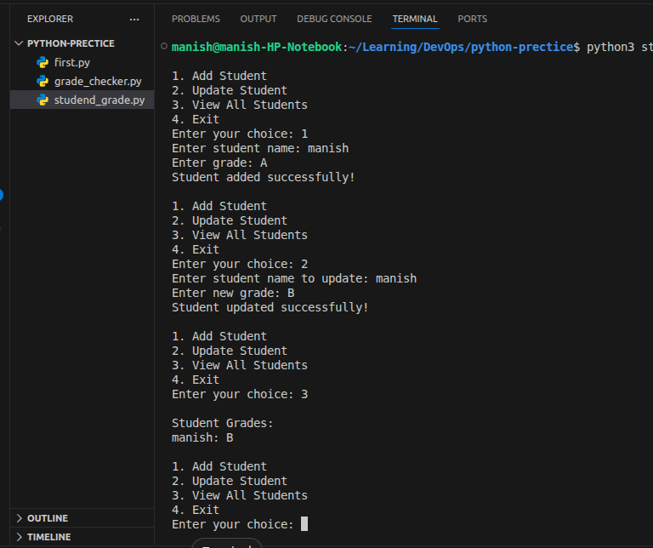

3. Write to a File

Explanation:
- open("file.txt", "w") → opens file in write mode
- write() → writes content
- close() → closes file to save changes
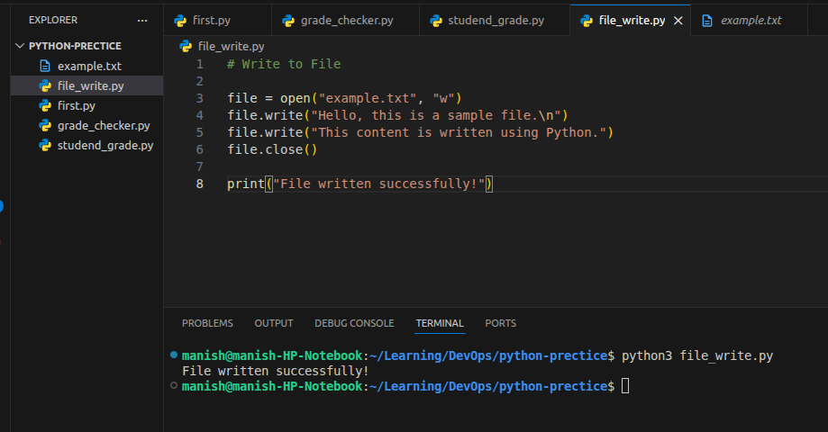
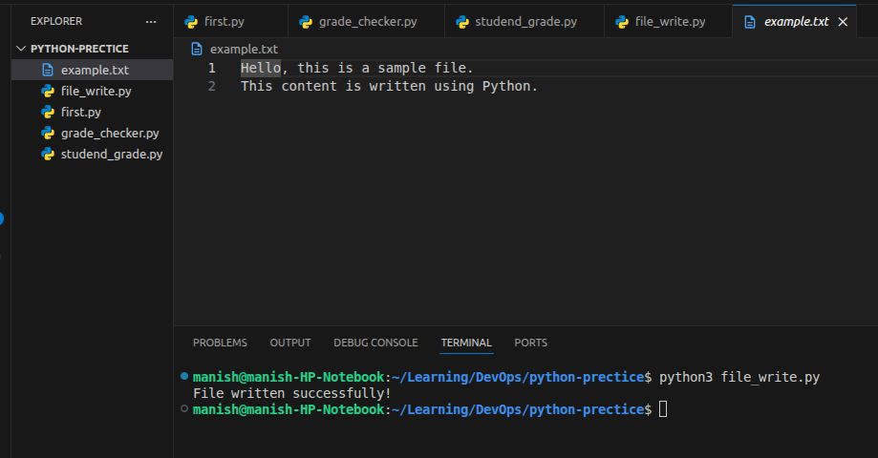

4. Read from a File

Explanation:
- open("file.txt", "r") → opens file in read mode
- read() → reads entire file content
- Prints the content

